

[German Journal of Veterinary Research](https://gmpc-akademie.de/journals/gjvr)

eISSN:2703-1322

## Article type (Review article, Research article, Short communication, Editorial, Case study

Title: Please insert the title

**First Name Last Name**1∗**, First Name Last Name** 2**, First Name Last Name** 3

1 Affiliation 1; Institute, University, Address, Country

2 Affiliation 1; Institute, University, Address, Country

3 Affiliation 1; Institute, University, Address, Country

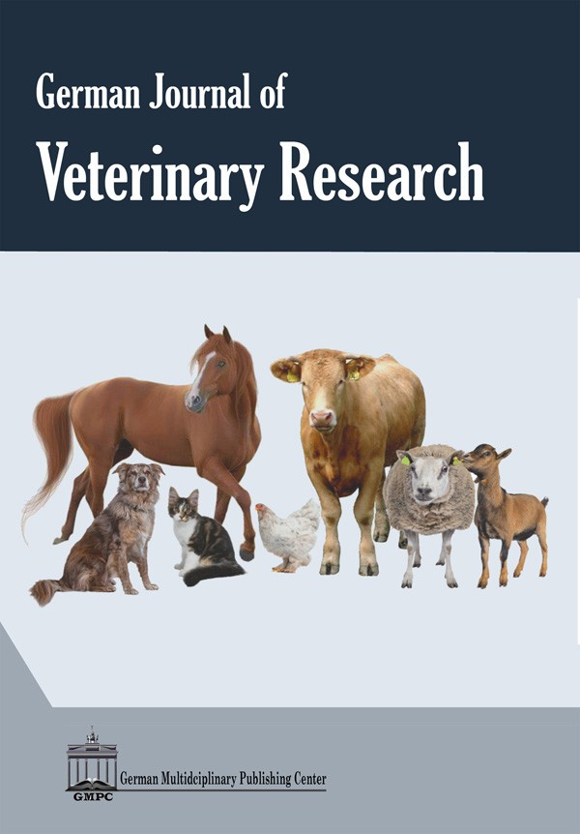



**Article History:** Received:

Accepted:

**\*Corresponding author:**

First Name Last Name

[e-mail@e-mail.com](mailto:e-mail@e-mail.com)

## Abstract

A single paragraph of about **250-300 words maximum**. For research articles, abstracts should cover the following item without heading: (i) Short introduction: Please provide background about the question addressed in a broad context. (ii) Aim of the study; (iii) Methodology: Please describe in brief the methodology; (iv) Results: Please summarize the main findings; (v) Conclusions: Please provide the conclusions or interpretations of your findings. Review papers and other article types have a more flexible structure. In case of short communications and case reports, the abstract should be **150-200 words**. Please note that each section in this template has a corresponding style.

**Keywords:** Keyword 1, Keyword 2, Keyword 3 (List 4-6 keywords)

**Citation**: Last Name, X. X., Last Name, Y. Y., and Last Name, N. 2024. Title. Ger. J. Vet. Res. 0 (0): 00-00

https://doi.org/xxxxxxxxx

## Introduction

Briefly state the research field carefully by citing key publications. Define the purpose of the work and its significance. References should be cited according to the journal instructions (please see below for further details in the reference section). Text citations: Use the names and dates in parentheses, e.g., as previously described (Wareth et al., 2020) or (Jones, 2020) or (Wareth and Jones, 2024). If two or more references by the same author(s) published in the same year are cited, they should be distinguished from each other by placing a, b, etc. after the year, e.g., (Song, 2020a, b; Hotzel and Patrik, 2019a, b). Submitted articles and personal communications are not acceptable. Bibliography: Please follow the format of the sample references and citations, as shown in this Guide. Using reference management software requires the authors to download and use the GMPC reference endnote style guidelines (See references).

## Material and Methods

Materials and Methods should be described with sufficient details. Sources of all materials used in the study must be described in detail. The original references for the applied techniques must be cited, and if modified, please describe briefly. New methods and protocols should be described in detail. All supplementary materials, e.g., GenBank accession numbers and IDs in any of the national and/or international repositories, should be specified and mentioned. Experimental animal work must be approved by the responsible ACUC at the institution with a clear statement.

For thesis reviews: material and methods can be described as the methodology in brief with references.

## *Materials subheading 1*

## *Materials subheading 2*

## Results

## This section may be provided alone or in combination with the discussion. It can be divided into subheadings. It should provide a concise and precise description of the results. If combined with the discussion, please interpret the results concisely in light of previously cited research and draw conclusions and recommendations.

## All figures and tables should be cited in the main text as Figure 1, Table 1, etc., and placed close to their first citation. Legends containing a short explanatory title and caption must be inserted under the figure and above the table.

## To create tables, authors should use the table option of Microsoft Word, fonts should be 9 pt. for legend and not less than 8 pt. in size for table contents).

## Please do not compress figures or photos to a lower resolution.

## Table 1. The table legend should be placed above the table. Fonts should be 9 pt. Tables should be placed in the main text near the first time they are cited.

|  |  |  |
| --- | --- | --- |
| Title 1 | Title 2 | Title 3 |
| Parameter 1 | data | data |
| Parameter 2 | data | data |
| Parameter 3 | data | data |

footer

## 

**Figure 1**. The figure legend should be placed under the figure and explain the figure in brief. The font is 9pt.

## Discussion

All results should be discussed and interpreted in comparison to the previous studies. The discussion should be concise and avoid repetition of the result section. Future research directions and recommendations may also be highlighted.

## Conclusions

# This section is not mandatory but can be combined with the discussion.

**Article Information**

Funding: Please use the following statements to describe the funding sources "This research received no external funding" or "This research was funded by the FUNDER, grant number XXX."

Conflicts of Interest: Declare conflicts of interest or state, “The authors declare no conflict of interest.”

Acknowledgments: In this section, you can acknowledge any administrative and technical support not covered by the author's contribution or funding sections.

Authors contribution. Declare author contribution or state, "All authors contributed equally to work”.

Supplementary Materials: Accepted files that have been referred to in the text (Suppl. Figure 1: title, Suppl. Table 1: title).

Publisher’s Note. The claims and data contained in this manuscript are solely those of the author(s) and do not represent those of the GMPC publisher, editors, or reviewers. GMPC publisher and the editors disclaim the responsibility for any injury to people or property resulting from the contents of this article.

## References

* Please ensure that every reference cited in the text is also present in the reference list.
* References should be checked carefully for accuracy and corrected to ensure the format matches precisely as in the template. Only essential references should be included. Authors can download the GMPC reference endnote style [at https://gmpc-akademie.de/ui-assets/resourses/GMPC-Endnote-Style.ens.](https://gmpc-akademie.de/ui-assets/resourses/GMPC-Endnote-Style.ens)
* Please include the DOI for all references
* Please include the names of the journals in full
* Please include the names of pathogens in italics

**Examples for references**

Yang, G., Chowdhury, S., Hodges, E., Rahman, M.Z., Jang, Y., Hossain, M.E., Jones, J., Stark, T.J., Di, H., Cook, P.W. et al., 2019. Detection of highly pathogenic avian influenza A(H5N6) viruses in waterfowl in Bangladesh, Virology, 534, 36–44. https://doi.org/10.1016/j.virol.2019.05.011

Douglas, R.G., and Samant, V.B., 2013. 3 - The vaccine industry. Vaccines (Sixth Edition), 2013, (W.B. Saunders, London), 33-43. http://dx.doi.org/10.1016/B978-1-4557-0090-5.00018-5

McCauley, J.W., Hongo, S., Kaverin, N.V., Kochs, G., Lamb, R.A., Matrosovich, M.N., Perez, D.R., Palese, P., Presti, R.M., Rimstad, E. et al., 2017. Orthomyxoviridae. 2017, (Elsevier, 389–410. http://dx.doi.org/10.1016/B978-0-12-800946-8.00021-5.